WELCOME TO SAUNDERSFOOT SAILING CLUB

Saundersfoot Sailing Club extends a warm welcome and honorary membership to all and your families during the course of Coppet Dinghy Week and hope that you will enjoy your time with us here in Saundersfoot. Accommodation details and local guides are available on www.saundersfootconnect.co.uk

Due to the COVID Pandemic the clubhouse will remain closed this year and the way in which we run the event will be modified. Changes are detailed in the Sailing Instructions. Registration is all being done online. We are hoping to carry out an event brief on the Saturday afternoon and will confirm timings in the SI’s. This will be done on the b
each near Scar Rock. The BeachMaster who will be located on the beach near Scar Rock will manage the sign on and off process each day and will have information on the days racing, weather, tides etc.

Chandlery is available at Dale Sailing, Ratseys Sailmakers and Brunell Chandlery at Neyland Marina and from South Wales Marine at Princes Gate, Narberth..

These are busy family beaches and you are requested to keep boats grouped together in the specified areas and to respect the safety and enjoyment of other beach users at all times, particularly when rigging, launching and recovering your boats from the sea.

Please do not launch or recover boats between the flags in the Lifeguard patrolled portion of the beach at any time.

Cars must NOT be taken onto the beach and boats should be pulled across the beach by hand to avoid disturbance and danger to other beach users. On Saturday there will be members from SSC on hand at the slipway near Walk on Water to give support as required. There are car parks in close proximity to the beach at Coppet Hall, on the Harbour and at the Regency Hall.

During the event Dinghies can be left on the beach well above the high water mark.

Road trailers should not be stored on the beach.

The Sailing Clubs dinghy park is already full and boats and trailers will not generally be allowed access onto the Harbour car park. We may be able to secure some storage space on the harbour by negotiation with the Harbour Master. The SSC Greeting team will advise if this has been possible on your arrival.

Thank you for your assistance in ensuring that the event runs smoothly and without causing inconvenience to other beach users.

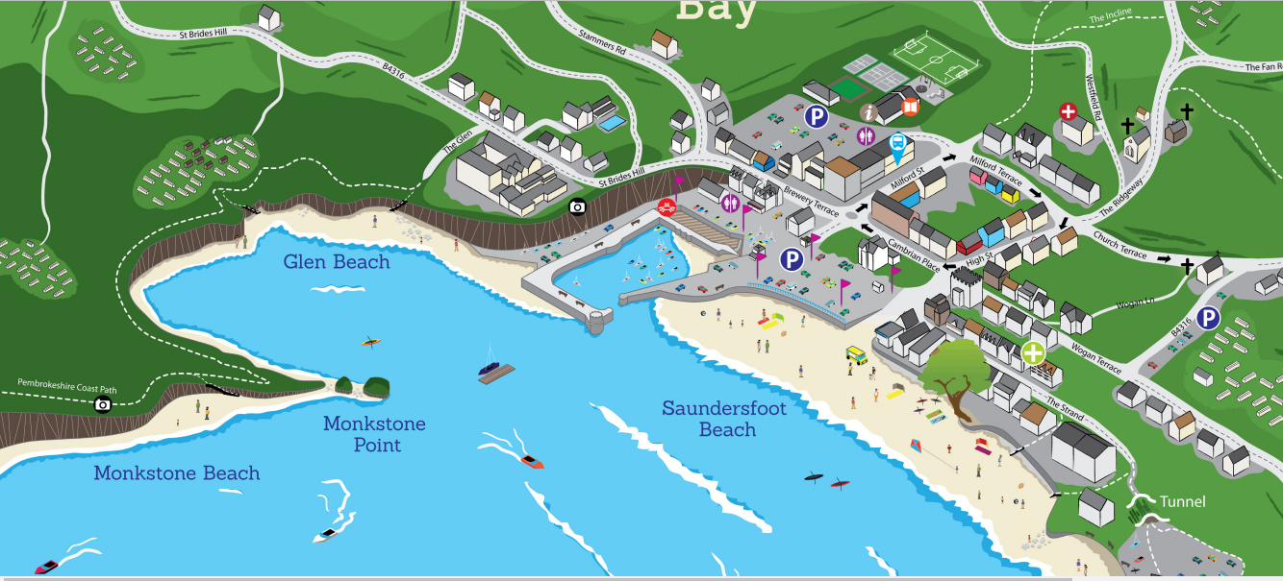
Beach Slipway
Beach Master
Coppet Hall
Sailing Club
Sailing Area

